**Assignment-2**

**Part 0:**

Personal GCP account could not be created even after several tries.

**Part 1:**

Execution times: **137s, 139s, 144s**

**Part 2:**

Used a friends GCP account to get these values: **12.2s, 11.9s, 12.1s**

**Part 3:**

Used TPU from Google Colab to complete this part: **0.0.035s, 0.036s, 0.036s**

**Part 4:**

Used my personal **GTX 1650M (1024 cores)** gpu. Times were **0.156s, 0.168s, 0.182s**

**Part 5:**

**TPUs gave the best performance** as TPUs are purpose-built for ML operations which rely heavily on matrix multiplication operations. GPUs are more general purpose than TPUs but are still more limited than CPUs. Thus, it is no surprise the 1024 core gpu outperformed a 22 core cpu.

**Part 6:**

CPU power consumption = 45 Watt

GPU power consumption = 50 Watt

TPU power consumption = ~100 Watts

Performance per watt (assuming total operations = 100 for the sake of calculations):

**CPU:0.185185**

**GPU: 12.8205**

**TPU: 27.77**

**(Formula = (No. of operations / execution time) / power consumption )**

**Combined Graph:**

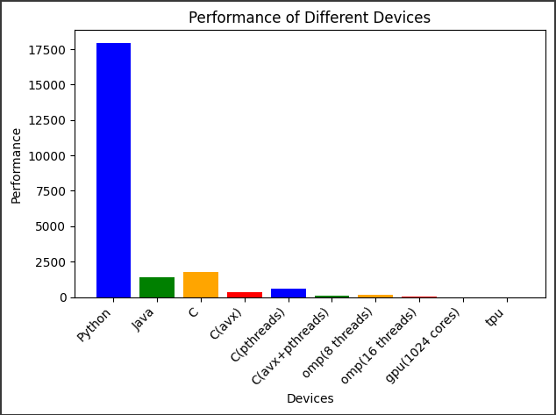

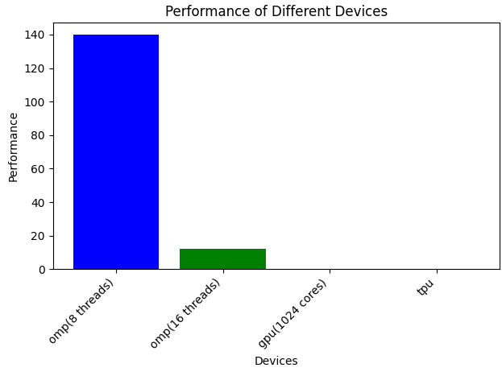

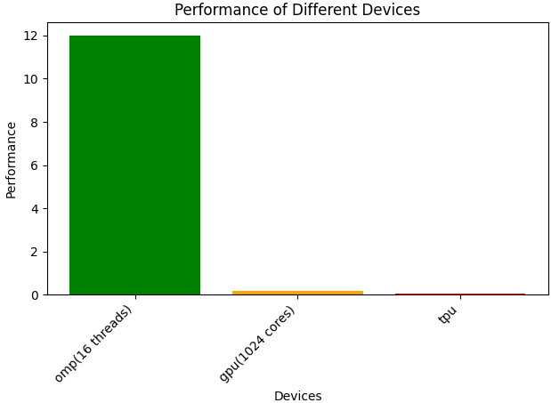

Proof of Execution of omp(16 threads) on GPU:

